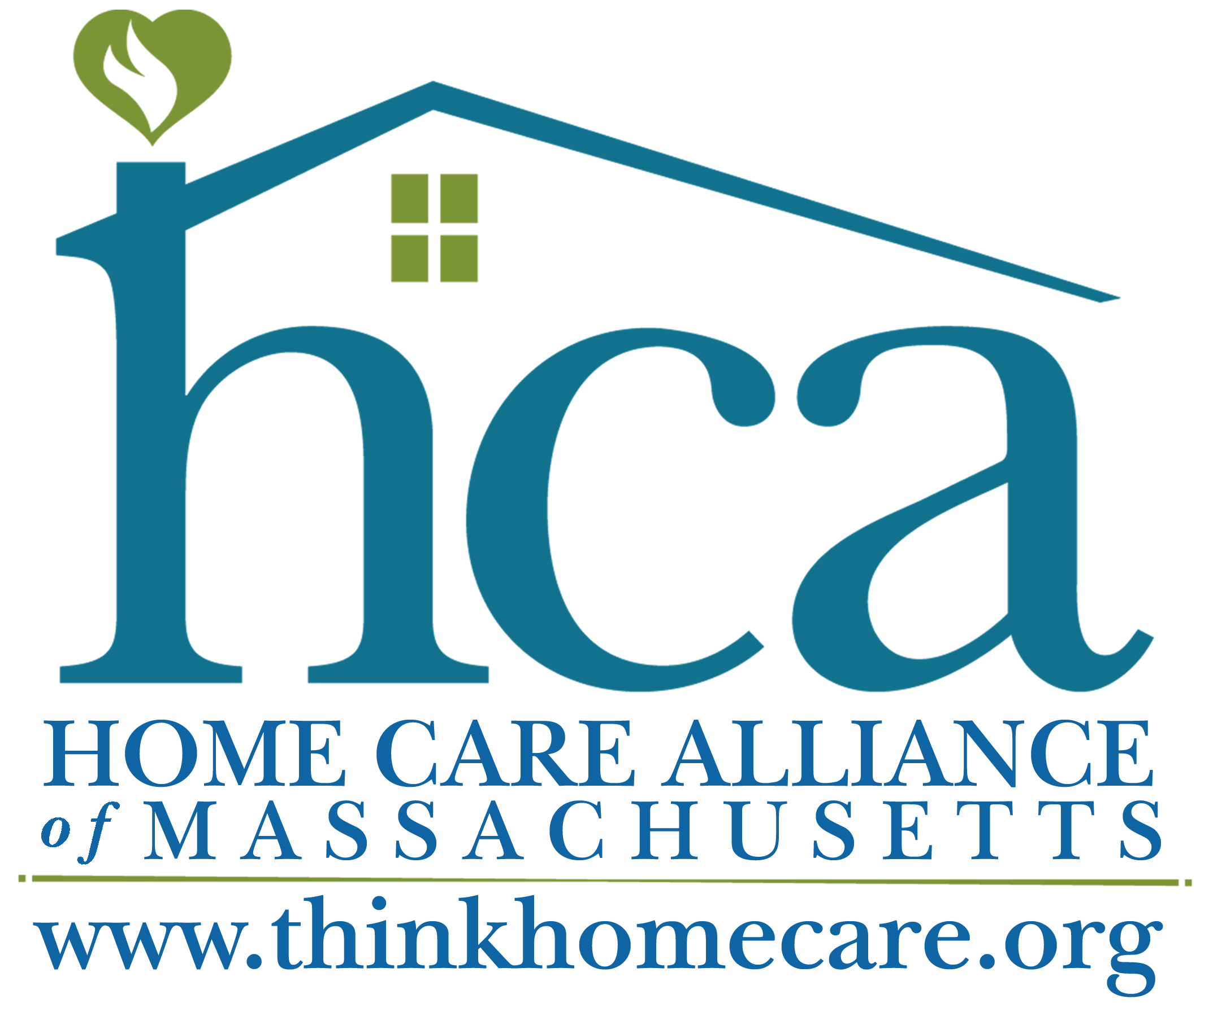

Certificate of Need
Senate Amendment #559
FY 2013 Budget Fact Sheet

Language: Mr. Michael O. Moore moved that the bill be amended, in Section 2, in item 4000-0600, by inserting the following:-“;provided further, that in order to be eligible to apply for Medicare certification and to bill MassHealth for home health services, any new applicant seeking to provide home health services must submit to a Certificate of Need (CON) review established by the Massachusetts Department of Public Health and assessed by an independent board appointed by the Governor, General Court, the Secretary of Health and Human Services, and the Home Care Alliance of Massachusetts. To obtain a CON, an application must be filed with said independent board in which the applicant demonstrates the need for or prove the cost efficiency of a new agency. The applicant must present to the department and board both evidence of unmet need and how the proposed agency would fit into the comprehensive health care delivery system of the service area. This application requirement shall not apply to Medicare-certified home health agencies providing care as of July 1, 2012.”

~MassHealth Managed Care Account (4000-0500)

Purpose: The Commonwealth has recently experienced rapid growth in the number of certified home health agencies while some areas remain underserved in particular visiting services like physical therapy and maternal-child health. This proposal is in response to that rapid growth as well as a lack of rigorous standards from the federal government, to control MassHealth spending and retain a tradition of quality home care.

Background:

- Massachusetts is one of only a small handful of states with neither licensure for home health care nor a Certificate of Need program for new agencies. Other state health professions, as well as nursing home administrators, are licensed by the Commonwealth.
- Providers can still enter the market in a particular geographic area if there is a need for a service or set of services.

Reasoning:
- The National Association for Home Care and Hospice collected data indicating that from 2001-2006, Medicare spending grew 2.5 times more in states where the number of home health agencies (HHA’s) increased as compared to states where the number of providers remained the same or decreased.
- After virtually no growth between 2001 and 2006, our state has seen an increase of 27 certified agencies in the past four years – an increase of more than 20 percent. This has occurred despite the fact that no area of the state is un-served or underserved for general home care services.
- The CMS Regional Office has indicated that there are 33 pending applications from potential home health agencies for Medicare/Medicaid certification in various stages of review.

Cost: The “independent board” named in the language would come at no cost to the state as it would be volunteer and appointed by government officials and stakeholder groups. A fee structure could be established for submission of CON applications to pay for additional staff time under the Department of Public Health’s Division of Health Professional Licensure.

Contact: James Fuccione, Director of Legislative & Public Affairs
Home Care Alliance of Massachusetts ~ jfuccione@thinkhomecare.org ~ (617) 482-8830

